# STUDENT INDUSTRIAL WORK EXPERIENCE SCHEME (SIWES)

**HELD AT**

**ZACRAC INTEGRATED LIMITED**

**2ND FLOOR, SOVEREIGN TRUST INSURANCE BUILDING, BESIDE FIRST BANK ALAGBAKA/AKURE, OBA ADESIDA ROAD,**

**AKURE, ONDO STATE**

**BY**

**OGHENEKARO EMMANUELLA AVWERUSUOGHENE**

**FSC/CSC/01801029**

**A SIWES REPORT SUBMITTED TO FACULTY OF SCIENCE,**

**DEPARTMENT OF COMPUTER SCIENCE,**

**EDO STATE UNIVERSITY UZAIRUE, EDO STATE**

**IN PARTIAL FULFILLMENT OF THE REQUIREMENT FOR THE AWARD OF BACHELOR OF SCIENCE (B.Sc. COMPUTER SCIENCE)**

**MAY – OCTOBER, 2021**

# DECLARATION PAGE

This is to show that the technical report on student's industrial work experience scheme at Zacrac Integrated Limited, 2nd Floor, Sovereign Trust Insurance Building Beside First Bank Alagbaka/Akure, Oba Adesida Road, Akure, Ondo State is prepared, compiled and submitted by Oghenekaro Emmanuella to the department of Computer Science having been accepted on meeting part of the requirement for the award of Bachelor in Science.



# DEDICATION PAGE

This report is dedicated to my parents MR & MRS OGHENEKARO for all their support throughout my education, my friends and Instructors. Mr Oni Segun Yemi and Mr Adegbite Gabriel Afolabi, for impacting knowledge into me and lastly my friends, Otti Daniel, Adewunmi Oluwasaanumi Roland, Fred Emmanuel and Inu John.

# ACKNOWLEDGMENT PAGE

All praise, adoration, and thanks go to my Creator for the gift of life within me, divine health, guidance and protection throughout my life and this program.My gratitude goes to my beloved parents Mr. & Mrs. Oghenekaro for their extensive support in my entire life. I want to thank Mr Adegbite Gabriel Afolabi, Mr Oni Segun Yemi for making my internship an interesting and life-changing experience.

Finally, I would like to thank everyone who in one way or another made a positive contribution during my training.

# ABSTRACT

In 2017, Zacrac started as a market research and public opinion poll company. We specialised in helping organisations conduct surveys, research their market and give feasibility studies. Overall, we focused on data collection services. Along the line, Zacrac embodied the idea of personal and organizational growth which it stands for. We transformed into a full-fledged data science and analytics company in recognition of the increasing demand for data analytics and training services. We also have other branches in the organization which involves giving a satisfactory implementation of Ux and UI design, Creating Web Apps for other companies.

This Industrial Training aims to free ourselves from the work environment, see the practical aspects of what we learn in class and also prepare us for the future that awaits us.

During my training, I had various responsibilities like involvement in the UI design of a financial management app, a Research topic on the impact of technological development in Akure, A landing page that attracts parents to enroll their kids in a high school, A team project where I had to redesign the slack dm, An individual project where I had to create a page that explains all plugins created by the organization, A team’s project where I and my teammates had to build a website for a company using the figma design created by the designers using Vue Js, A team project with my course mates where we had to redesign and implement the frontend of Edo state university uzuaire website using html and tailwind css.

My Industrial Training gave me a right publicity in particular withinside the place of offering answer as its totally primarily based totally on IT. My Industrial Training has additionally modified my technique of wondering each time trouble occurs, my schooling has given me capacity to preserve calm and assume productively each time I'm confronted with a trouble.

This report provides comprehensive information on the company that hosted the Industrial training course for student, the ongoing standards of the equipment and devices used in numerous departments within the company, and the lessons learned at the end of the day.

# 

Table of Contents

STUDENT INDUSTRIAL WORK EXPERIENCE SCHEME (SIWES) 1

DECLARATION PAGE 2

DEDICATION PAGE 3

ACKNOWLEDGMENT PAGE 4

ABSTRACT 5

CHAPTER ONE 8

1.1 INTRODUCTION TO INDUSTRIAL TRAINING(IT) 8

1.2 OBJECTIVES OF INDUSTRIAL TRAINING 8

1.3 SIWES REGULATORY AGENCIES 8

1.4 BENEFITS OF INDUSTRIAL TRAINING TO STUDENTS 10

CHAPTER TWO 11

2.1 HISTORY OF ZACRAC 11

2.2 OBJECTIVE OF ZACRAC 11

2.3 COMPANY’S ORGANIZATIONAL STRUCTURE 12

2.4 VARIOUS DEPARTMENTS/UNITS IN ZACRAC AND THEIR FUNCTIONS 12

2.4.1 Tech and Developers 13

2.4.2 Operations and Projects Management 13

2.4.3 Administration and Customer Representative 13

2.4.4 Marketing and Sales 13

2.4.5 Account and Finance 13

2.4.6 Training 13

CHAPTER THREE 13

3.1 ACTIVITIES CARRIED OUT DURING THE PERIOD OF ATTACHMENT 14

3.2 PROJECT EXECUTED 14

PROJECT 1 15

PROJECT 2 19

PROJECT 3 20

PROJECT 4 21

PROJECT 5 26

PROJECT 6 30

PROJECT 7 32

PROJECT 8 34

3.3 EXPERIENCE ACQUIRED 39

Working with some Software’s: 39

Working with Version Control System (Git and Github): 39

Personal relationship with people: 39

Working on project with a team: 39

CHAPTER FOUR 40

4.1 PROBLEMS ENCOUNTERED 40

Anaconda setup issues: 40

PC issues: 40

Network issues: 40

Running into bugs: 40

4.2 PROBLEMS SOLVED 40

CHAPTER FIVE 41

5.1 CONCLUSION 41

5.2 RECOMMENDATION 41

REFERENCE 42

# CHAPTER ONE

## 1.1 INTRODUCTION TO INDUSTRIAL TRAINING(IT)

Student Industrial Work Experience Scheme (SIWES) is one of the Industrial Training Funds (ITF) programs. It was designed to give Nigerian students studying occupationally-related courses in higher institutions the experience that would supplement their theoretical learning (Chukwurah, 2007).

The Student Industrial Work Experience Scheme (SIWES) was established by ITF in 1973 with the aim of exposing students to machines and ways to safeguard work areas and workers in the industries/companies, offices, laboratories, hospitals and other organizations. The main reason behind SIWES was to expose students to industrial or corporate environments and enable them to develop occupational competencies so that they can readily contribute their quota to national economic and technological development after graduating.

The major benefit to students who partake in the SIWES program are the skills and competencies acquired during the program. The relevant production skills remain part of the recipients (student) of industrial training as a life-long asset which cannot be taken away from them. This is possible because the knowledge and skills acquired through the training are internalized and become relevant when required to perform jobs or tasks.

## 1.2 OBJECTIVES OF INDUSTRIAL TRAINING

The Industrial Training Fund policy established by SIWES in 1973 which outlined the objectives of the scheme are as follows:

1. Provide students with an opportunity to apply theoretical knowledge in real work situations, thereby bridging the gap between university or higher learning institution work and actual practice.
2. Prepare and expose students for work or jobs they are likely to face after graduation.
3. Exposes students to work methodology and techniques in handling equipment and machineries that may not be available in the university.
4. Provides an avenue for students in institutions of higher learning to acquire industrial skills and experiences in their field of study.
5. Make transition from university to the world of work easier and thus enhance contest for later job placement.
6. Strengthen the link between employers, universities and Industrial Training Funds (ITF).

## 1.3 SIWES REGULATORY AGENCIES

The Federal Government, the Industrial Training Fund (ITF), the supervising agency, National University Commission (NUC), Employers of labour and institutions have specific rules to play in the management of SIWES.

The roles are:

1. **The Federal Government:**
2. To provide adequate funds to the ITF through the Federal ministry of Trade and Investment for the scheme.
3. Formulate policies to guide the running of the scheme nationally
4. To make it mandatory for all ministries, companies and parastatals, to offer places for attachment of students in accordance with the provision of decree NO 47 of 1971 as amended in 1990.
5. **The Industrial Training Funds (ITF):**
6. To formulate policies and guidelines on SIWES for distribution to all the SIWES participating bodies.
7. Provide logistic materials needed to administer the scheme.
8. Organize orientation programs for students prior to attachment and provide information on companies for attachments and assist in industrial placement of students.
9. Supervise students on industrial attachment.
10. Accept and process Master and Placement lists from institutions and supervising agencies.
11. Vet and process students’ logbooks and ITF Form 8.
12. **The Supervisory Agencies (NUC, NABTEB, NCCE, etc.):**
13. To ensure the establishment and accreditation of SIWES units/directorates in institutions under their jurisdiction.
14. To vet and approve Master and Placement lists of students from participating institutions and forward the same to ITF.
15. Fund SIWES directorate in participating institutions and to direct for the appointment of full-time SIWES coordinator/Director.
16. Review programs qualified from SIWES regularly.
17. Participate in the biennial SIWES conferences and seminars in conjunction with ITF.
18. **The Employers:**
19. Accept students and assign them to relevant on-the-job training.
20. Provide tailor-made training programs for the students.
21. Attach experienced staff to students for effective training and supervision on a ratio of 1:10 (staff: students).
22. Control and discipline students like permanent staff.
23. Provide medical care for students within the limit of employer’s conditions of service.
24. Permit representatives of ITF and Institutions based supervisors to visit the students on attachment.
25. Grade students in the assessment Form and the ITF Form.
26. **The Institution:**
27. Appoint SIWES coordinator in schools.
28. Prepare and submit Master and Placement lists to the respective coordinating agency and ITF.
29. Organize orientation programmes for students to prepare them for industrial training.
30. Supervise students on attachment and sign their logbooks.
31. A minimum of three visits should be made to students by the institution’s supervisors during the period of attachment.
32. Submit comprehensive reports on the scheme to the ITF after the programme.
33. **The student:**
34. To attend the institution's SIWES orientation programme before going on industrial attachment.
35. Comply with the employer’s rules and regulations during attachment.
36. Keep proper records of training activities and other assignments in the logbook.
37. Arrange their own accommodation during the period of attachment.
38. Submit logbooks, reports and other documents related to SIWES as required by their institution at the end of the training period.
39. Submit to ITF through their institution, Evaluation Form (ITF Form 8) completed by the students, the employer and the institution.
40. Avoid changing the place of attachment except in special circumstances and with the permission of your center Director and the SIWES Directorate.

## 1.4 BENEFITS OF INDUSTRIAL TRAINING TO STUDENTS

1. The students are exposed to the professional work environment.
2. During the period of exposure, the skill of the students is broadening and his/her efficiency is enhanced.
3. The application of theoretical knowledge gained in class is seen in real life scenarios.
4. It helps in increasing self-confidence and identifying their own competencies.
5. It cultivates the leadership ability of the students and gives them the responsibility to execute and perform a given task.
6. It improves the versatility of the student and helps them in boosting their career.

# CHAPTER TWO

## 2.1 HISTORY OF ZACRAC

Zacrac is an indigenous fast-growing firm dedicated to helping individuals that organizations make better decision using data, creating application and user-friendly designs.

Founded by Engr. Adewale Adeyemo in September 2016, with the core in Market research and public opinion pool helping organizations conduct surveys, research their market and give feasibility studies, overall focused was on data collection. The company has since grown and developed expertise in various complex areas of Data Science and Software Engineering. Zacrac’s staffs consists of experiences individuals who possess vast and up-to-date knowledge with technologies ad in helping individuals and firms leverage on data to make quality decisions-key in data collection, analytics, reporting and training to ensure clients achieve progress. Amongst her teams are certified professional senior analysts, writer, frontend developers, UI/UX designers, digital marketers and graphics designers.

Zacrac also stands as an institute that trains and produce ready-made data scientist/analyst, software developers who are ready to go into society and solve problems.

**Core services rendered by Zacrac**

1. IT Training/Education,
2. To help individuals and organizations make decision using data analysis, survey and training
3. To help individuals and organizations in creating efficient web applications and user-friendly designs.

## 2.2 OBJECTIVE OF ZACRAC

1. Building high performance applications to solve problems across various sectors or disciplines such as Agriculture, Health, Accounting, Entertainment, Education etc.
2. Training students or individuals with the hope of recruiting the best and also referring others to other IT firms and mentoring them with start-up ideas to launch their ideas.
3. To ensure the students or individuals come off as professional in order to serve as a source of income to them, thereby helping to boost the economy of the nation and also creating employment.
4. To identify client’s current strategy, analyze existing data and patters and research, organize and evaluate new data.
5. To train students or individuals by creating and maintaining a flexible industry-relevant curriculum and testing knowledge of students using real-life projects.

## 2.3 COMPANY’S ORGANIZATIONAL STRUCTURE

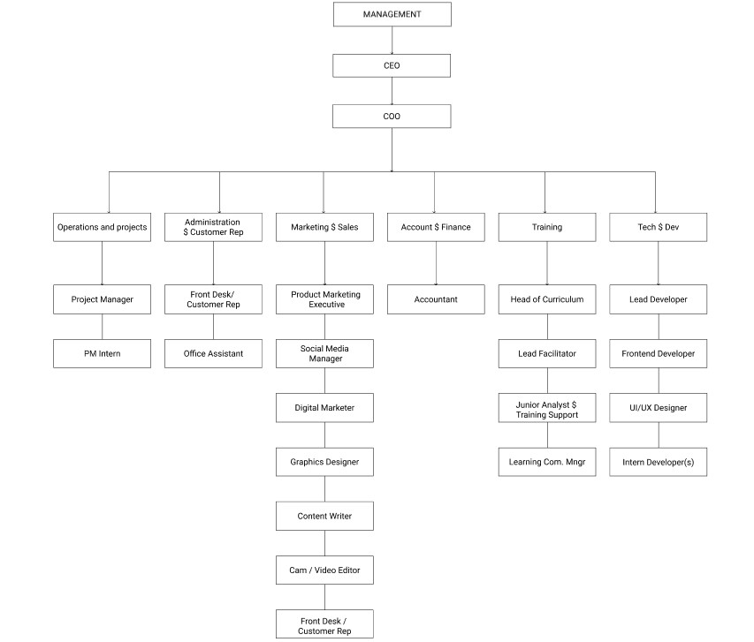

## 2.4 VARIOUS DEPARTMENTS/UNITS IN ZACRAC AND THEIR FUNCTIONS

The various departments at Zacrac are listed below including their functions.

### 2.4.1 Tech and Developers

The Tech and Developers team at Zacrac are in charge of creating user friendly, scalable and responsive web applications. They are also in charge of creating user interfaces that will be implemented by other software application development departments. They make use of Figma and Adobe XD for creating user interfaces. Below are their functions:

1. Create website layout/user interface by using standard practices.
2. Write well designed, testable, efficient code by using best software development practices.
3. Maintenance and upgrade of existing web applications.
4. Improve the look and feel of interactive software products.
5. Creating an overall concept for user experience within a webpage, ensuring all interactions are intuitive and easy for customers.

### 2.4.2 Operations and Projects Management

Operations management and project managers at Zacrac, deals with approaching day-to-day as well as strategic business issues systematically. They also are involved in the planning, organizing, motivating and controlling resources to achieve a specific goal.

### 2.4.3 Administration and Customer Representative

The Admin and Customer Representative Unit attends to customers with complaints and questions, gives customer’s information about products and services, takes order and process returns.

### 2.4.4 Marketing and Sales

The marketing and sales department at Zacrac, serves as an intermediary between customer and production. Customers discuss their needs concerns or requests with the sales personnel. In return the sales personnel relay this information to the various departments in the company

### 2.4.5 **Account and Finance**

The accounting and finance department at Zacrac, is responsible for ensuring the efficient financial management and financial controls necessary to support all business activities

### 2.4.6 Training

Some Tutors at Zacrac are in charge of training participants to become good at their field. Fields like Data Science, Web Development, UI and UX designers

# CHAPTER THREE

## 3.1 ACTIVITIES CARRIED OUT DURING THE PERIOD OF ATTACHMENT

During the 24 weeks attachment at Zacrac, I was exposed to the knowledge of data science, web development and UI/UX. I started learning the basic knowledge of data science, the importance of data science, creation of surveys, basic knowledge of excel, different statistical methods and statistical test, basics of python and how to implement the statistical methods in python, also learnt how to use some libraries like pandas which lasted for 5 months. After that training I joined the web development training, I learnt the basics of HTML, CSS and Js, then an introduction to Vue Js which lasted for about two and the half weeks. Then I moved on to UI and Ux, where I was taught the principles of designing a website that satisfies the user. The UI/UX program lasted for two and the half weeks.

After my training on the fundamentals of Data Science, I learnt how to use excel to search for names using VLOOKUP, I learnt how to analyze some dataset given as exercises using excel, I also learnt how to draft questions to carry out research, also learnt how to create a survey using google form and typeform. Also learnt how to get responses from the form by linking them to google spreadsheet / download the csv file. I also learnt the introductory aspect of python like Loop, conditional statements, list, tuples, dictionaries,

After my training on the fundamentals of frontend development, I learnt how to code a pixel perfect website with the help of the figma design created. I learnt how create components and route pages in a website using Vue Js. Also learnt how to consume API’s using axios in Vue Js. I personally learnt tailwind CSS. I created a personal portfolio using tailwind CSS.

## 3.2 PROJECT EXECUTED

Below are some selected projects I worked on during my training at Zacrac both personal and group (team).

1. UI design of a financial management app
2. A landing page for a car company (UI Design)
3. A landing page for a high school (UI Design)
4. A team’s project where we had to redesign the UI of Slack’s dm for a company (Zuri Organization)
5. An individual project where I had to create a page that explains all the plugins created by the organization (Zuri Organization)
6. A team’s project where I and my teammates had to build a website for a company using the figma design created by the designer’s using Vue Js (Zuri Organization)
7. Redesigned Edo State University Uzuaire Website and Implementation.
8. A Research topic on the impact of technological development on Youths in Akure South Local Government Area (Data Science)

### PROJECT 1

#### UI design of a financial management app

Financial Management application, helps individuals saves their money rather than allowing users squander their money. This UI was designed using figma.

Figma Link: <https://www.figma.com/file/TzJVYB1e87aT2RQ9CJZRig/Milestone2?node-id=30%3A123>

(Milestone 3 page)



**SPLASH SCREEEN 1 SPLASH SCREEEN 2 SPLASH SCREEEN 3 SPLASHSCREEEN 4 LOGIN PAGE**

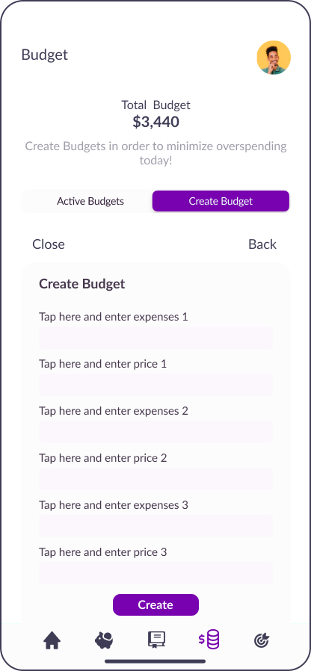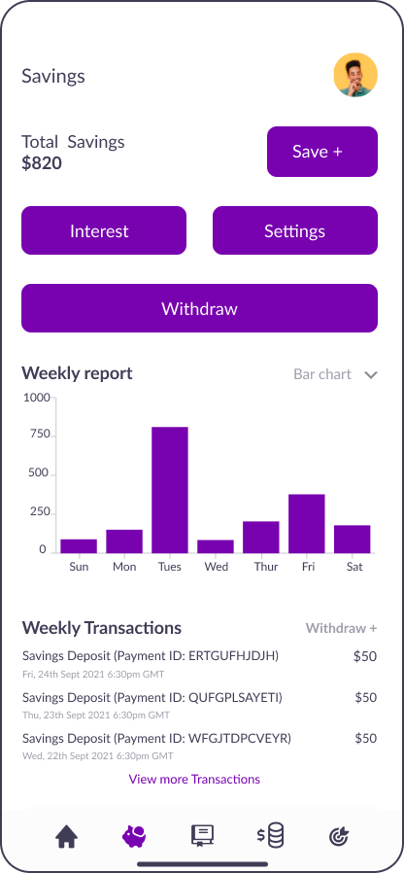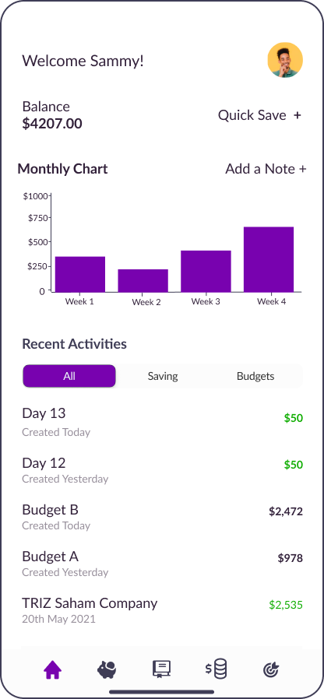  **SIGN UP PAGE HOME SCREEN SAVINGS PAGE ACTIVE BUDGET PAGE CREATE BUDGETS**

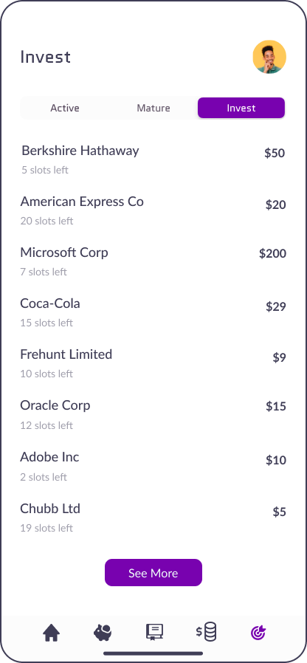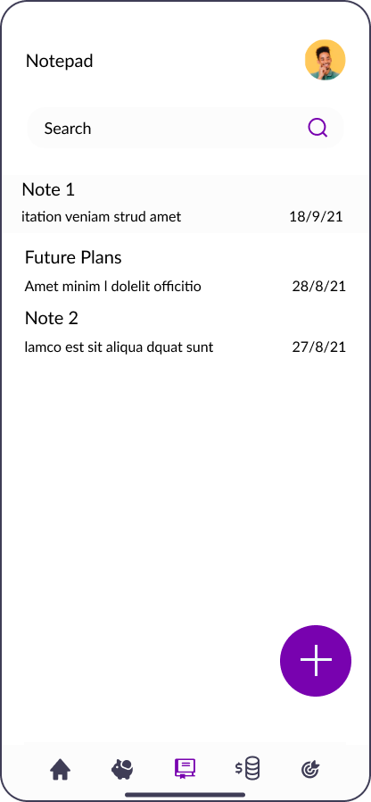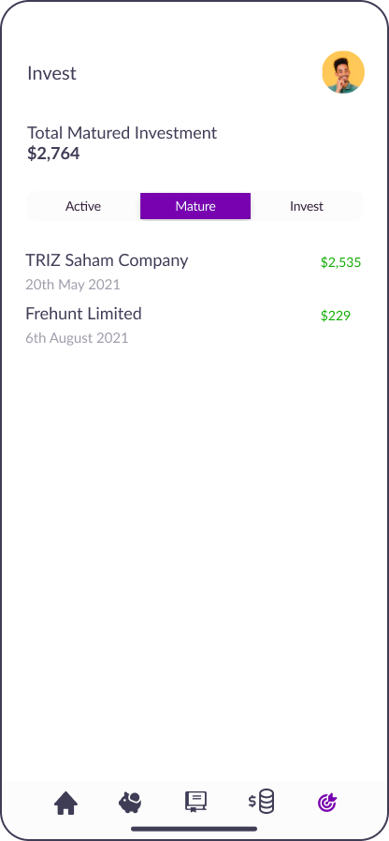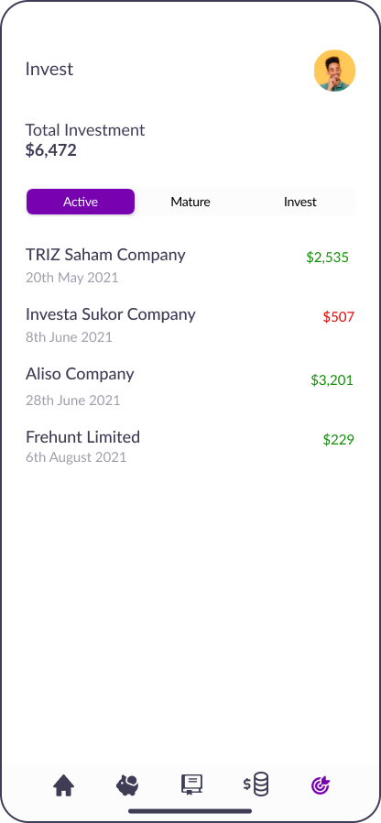

**ACTIVE MATURED INVEST** **PAGE LIST OF COMPANIES NOTEPAD**

**INVESMENT INVESTMENT YOU CAN INVEST IN**

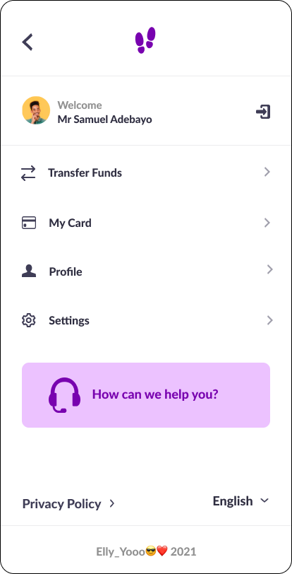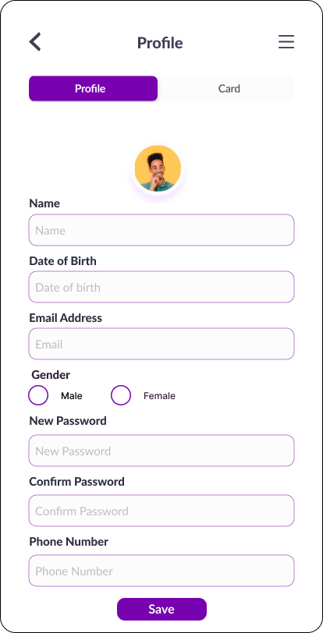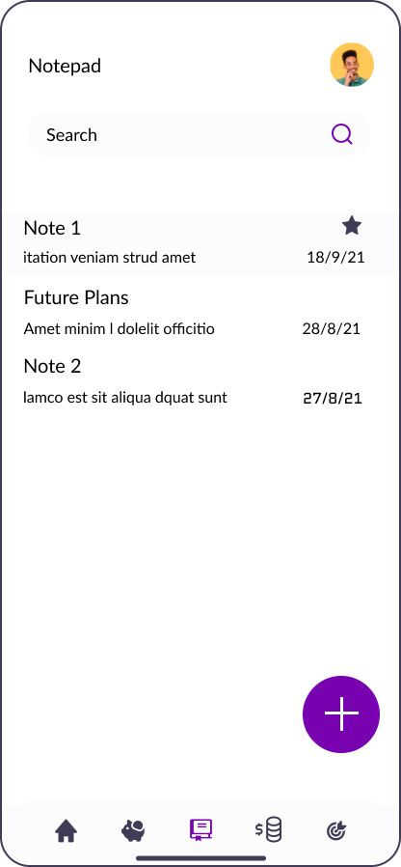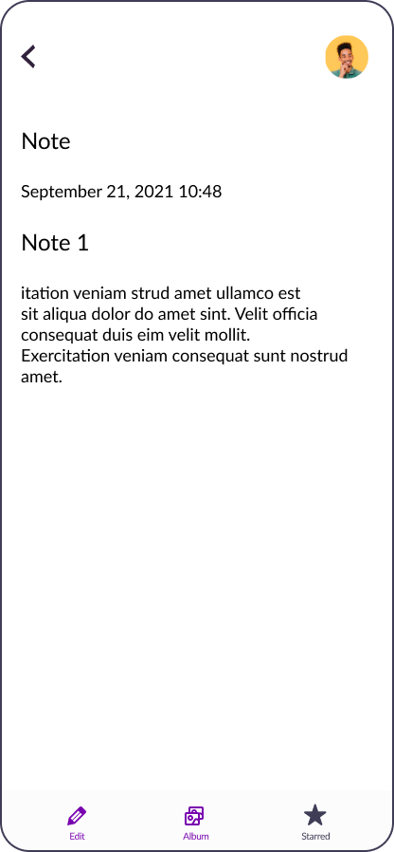

**NOTEPAD PROFILE AND CARD PAGE**

More of these pages are on the figma file!

<https://www.figma.com/file/TzJVYB1e87aT2RQ9CJZRig/Milestone2?node-id=30%3A123>

### PROJECT 2

#### A landing page for a car company (UI Design)

Figma Link:

<https://www.figma.com/file/UTI1rHZoZDx5nXb7RKXol3/design-2?node-id=0%3A1>



### PROJECT 3

#### A landing page that attracts parents to enroll their kids in a high school (UI Design)

Figma link:

<https://www.figma.com/file/xzIZtbjCs1rxLQaSOX9EPR/HNG-Task-1?node-id=5%3A29>

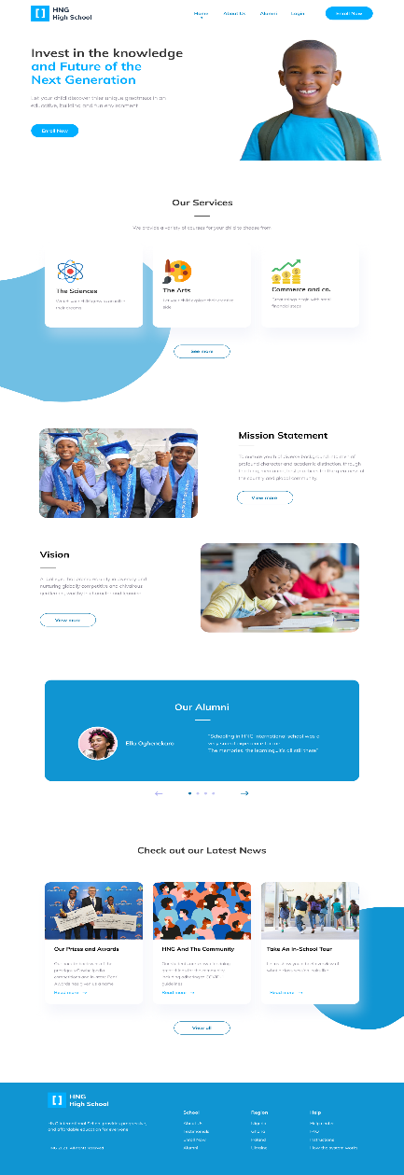

### PROJECT 4

#### A team project where we had to redesign the UI of slack’s dm for a company (Zuri organization)

I designed some slack’s Dm features like:

1. Add Reaction
2. Add more actions
3. All direct messages
4. Search DM
5. Search Messages
6. Search Messages in a Dm
7. Pin Messages
8. View Pinned Messages
9. Un-pinned Messages
10. Remove pinned Messages Modal

Figma Link: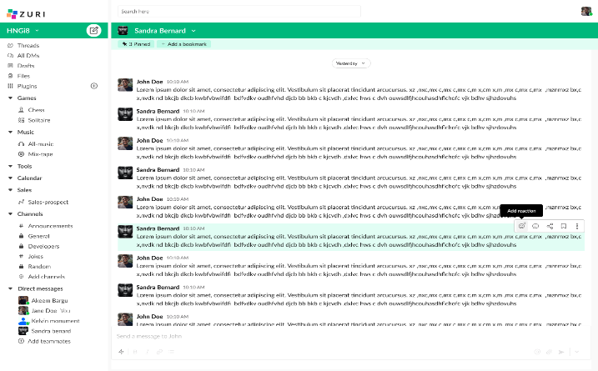<https://www.figma.com/file/9h1CwL2iAwKHWwdffW71Lo/Zuri?node-id=0%3A1>

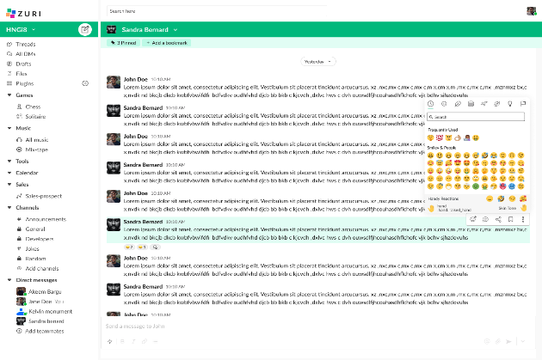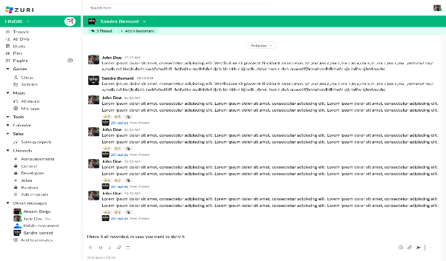

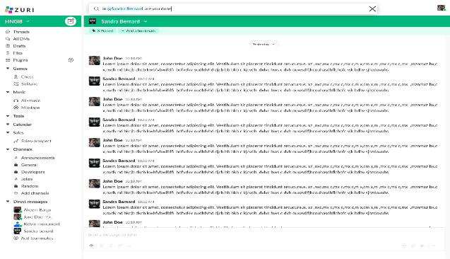**ADD REACTION**

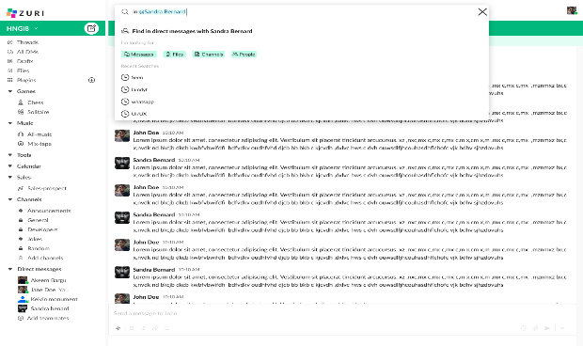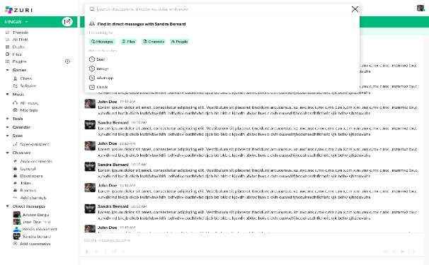

**SEARCH MESSAGES IN A DM**

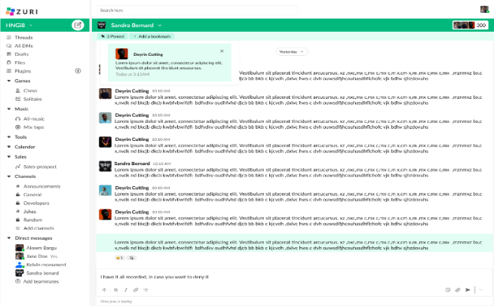

**VIEW PINNED MESSAGES**

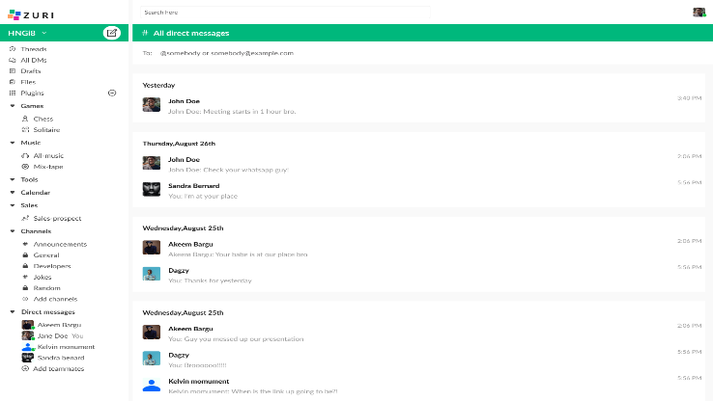

**ALL DIRECT MESSAGES**

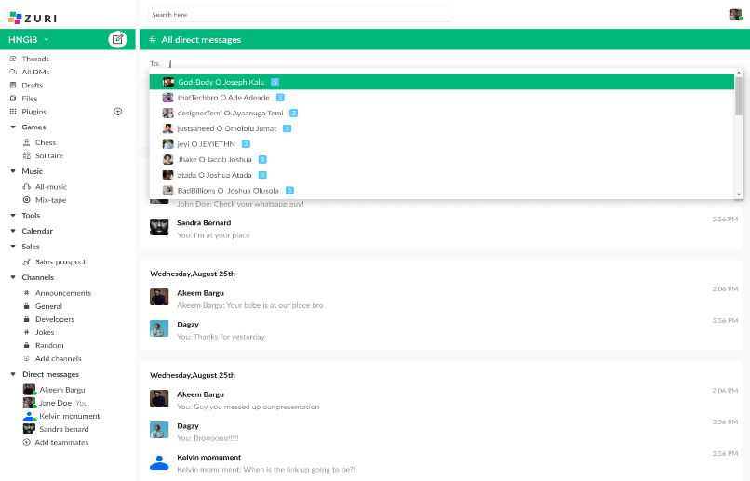

**DM SEARCH**

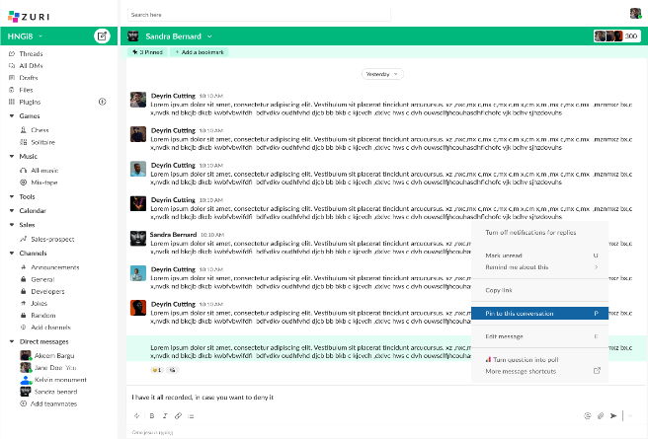

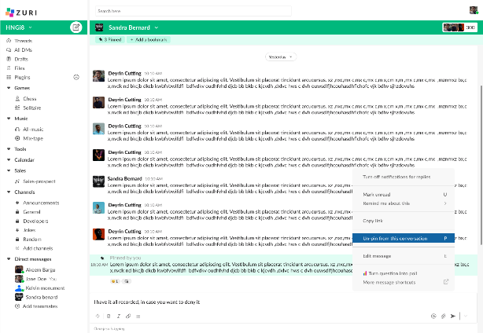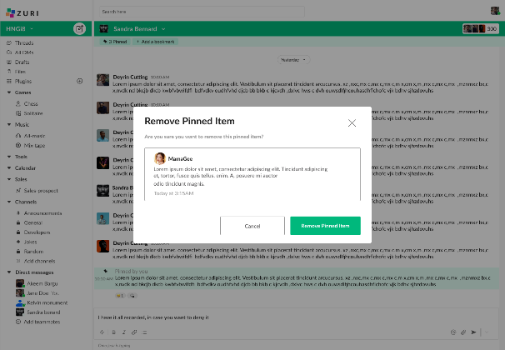

**PIN AND UNPIN A MESSAGE**

### PROJECT 5

#### An individual project where I had to create a page that explains all plugins created by the organization using React Js (Zuri organization)

The live link: <https://zuri.chat/plugins>

Pull Request link: <https://github.com/zurichat/zc_main/pull/1851>

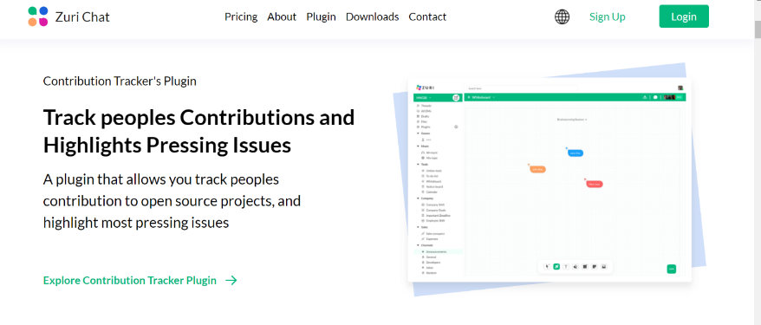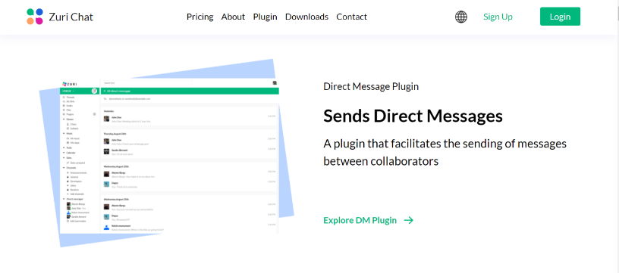

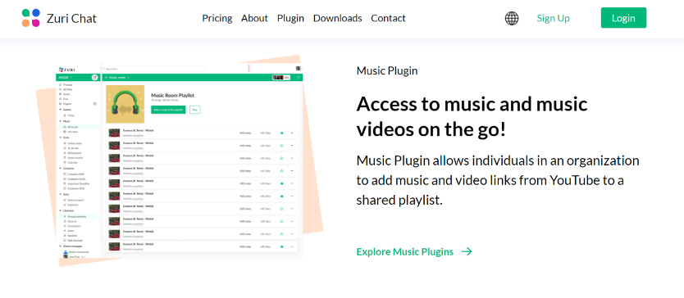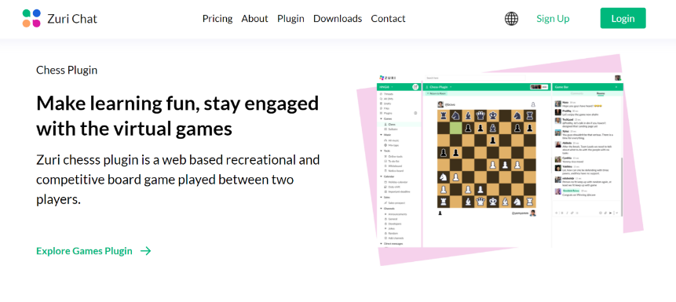

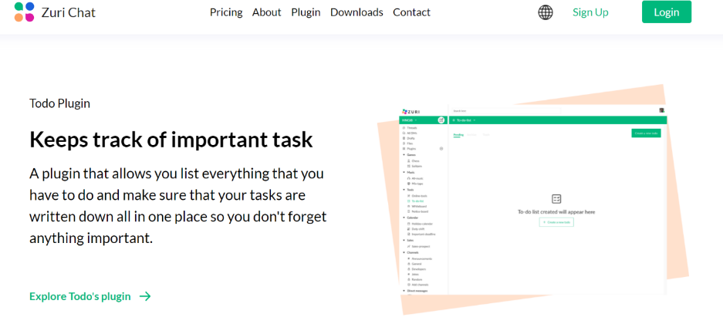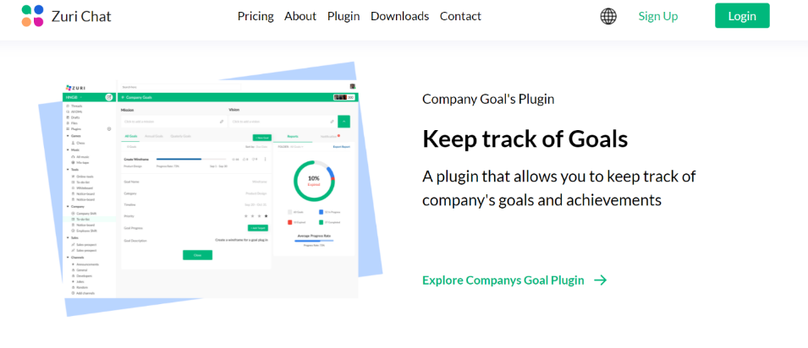

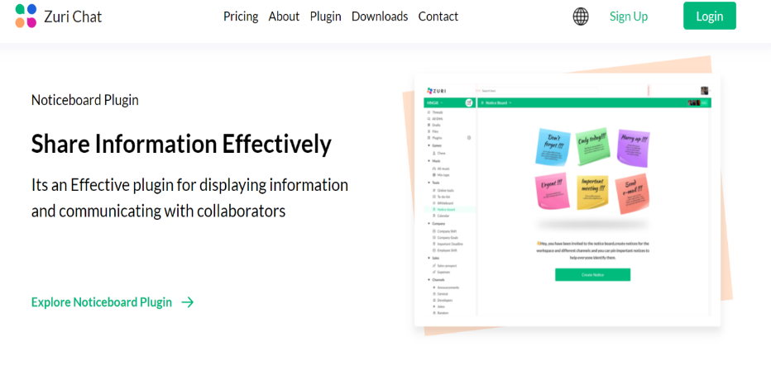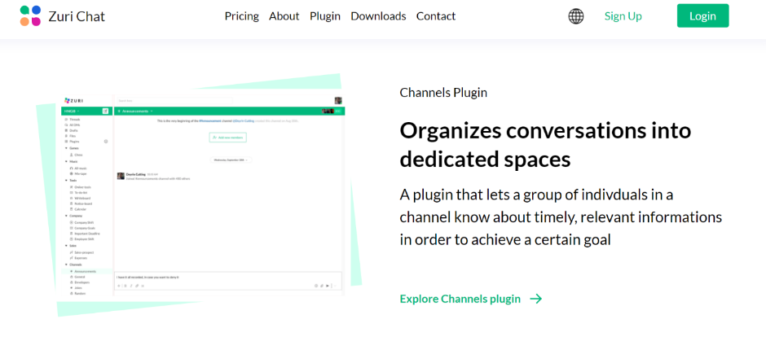

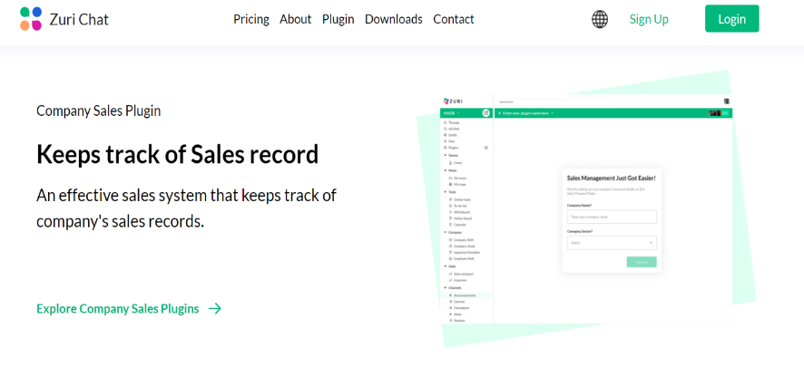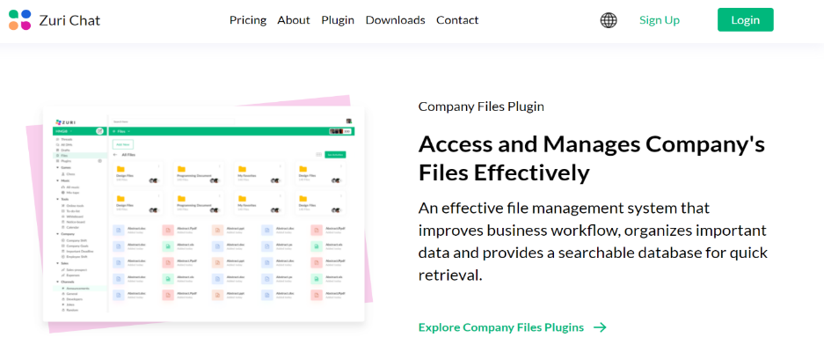

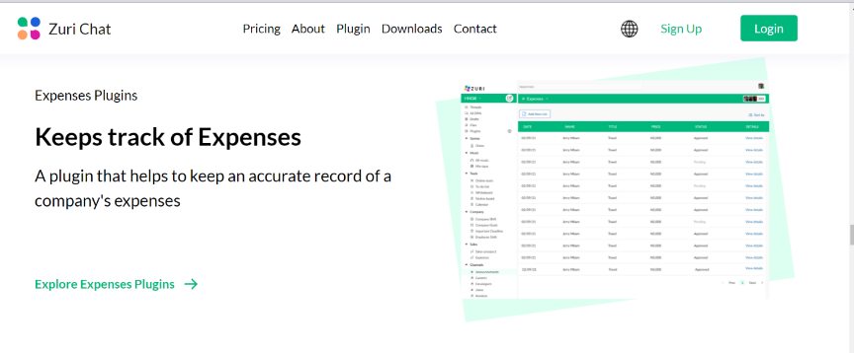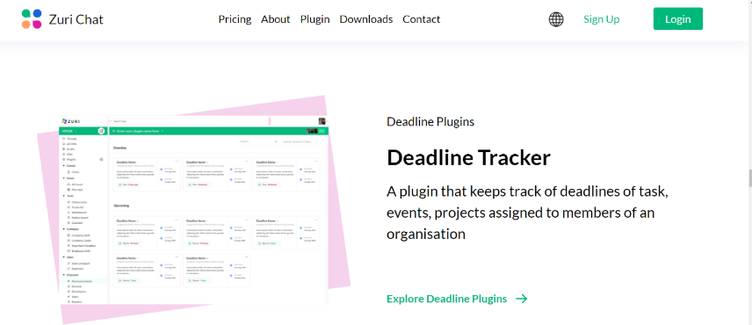

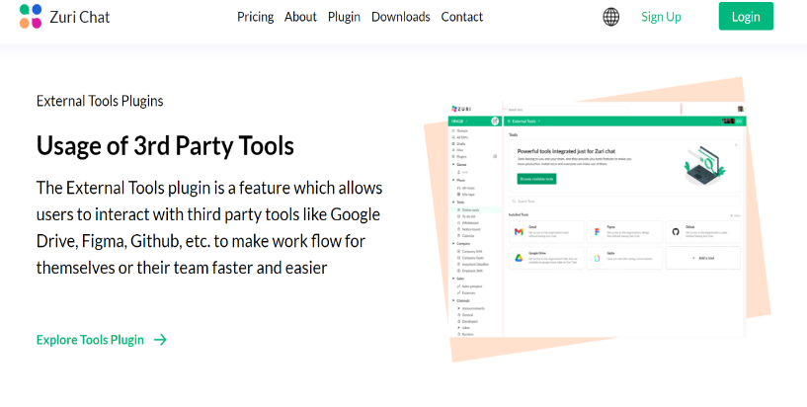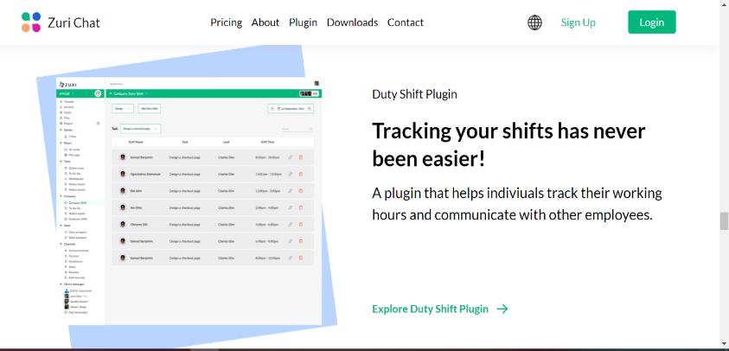

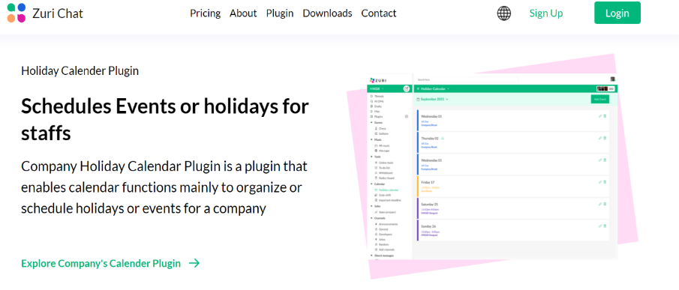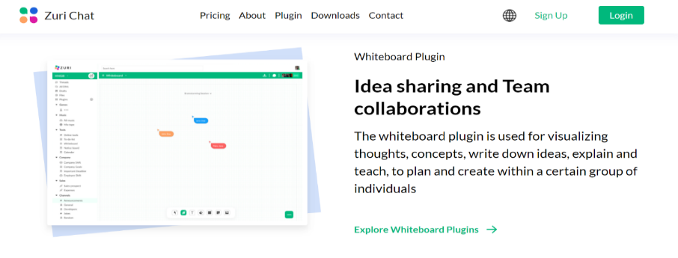

**LIST OF PLUGINS**

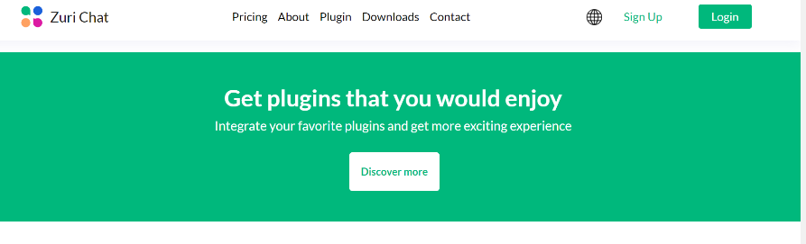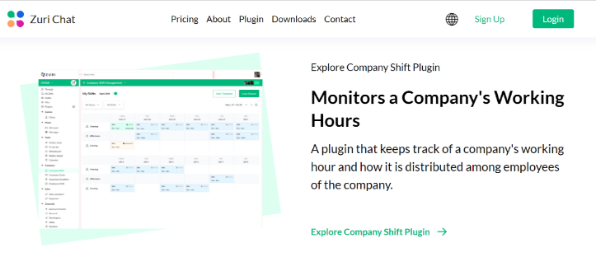

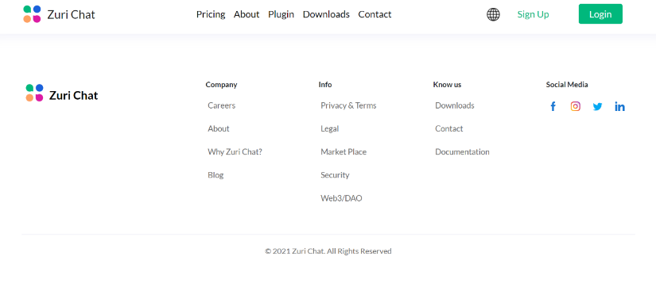

**SUBSCRIBE FOR LATEST UPDATES** **FOOTER**

### PROJECT 6

#### A team’s project where I and my teammates had to build a website for a company using the figma design created by the designer’s using Vue Js (Zuri Organization)

The aim of the website was to track the total number of interns per year and get to know their current status.

My Contribution: I worked on a reusable header Component and subscribe functionality.

LIVE LINK: <https://zuriprogresstracker.netlify.app/>

PULL REQUEST LINKS:

<https://github.com/paisoncodes/zuri_team_progress_tracker/pull/9>

<https://github.com/paisoncodes/zuri_team_progress_tracker/pull/16>

<https://github.com/paisoncodes/zuri_team_progress_tracker/pull/65>

<https://github.com/paisoncodes/zuri_team_progress_tracker/pull/101>

<https://github.com/paisoncodes/zuri_team_progress_tracker/pull/111>

to confirm if the subscribe functionality really works, you can check this endpoint that shows the list of subscribers of our newsletter.

<https://zuri-progress-tracker.herokuapp.com/api/v1/subscribers/>

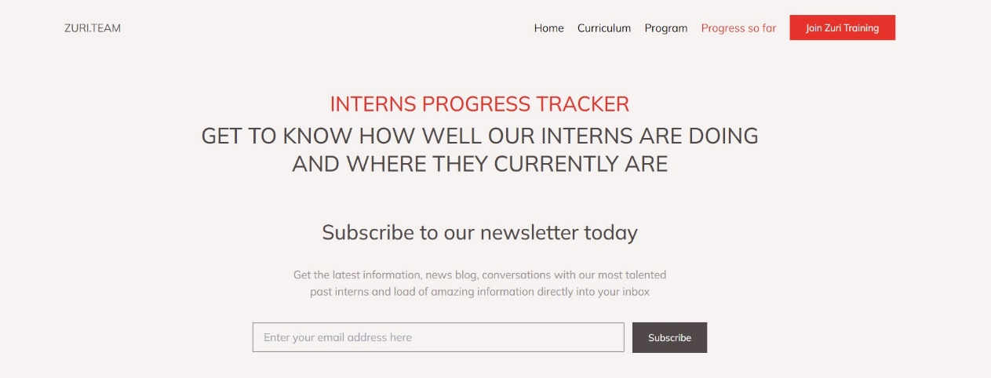

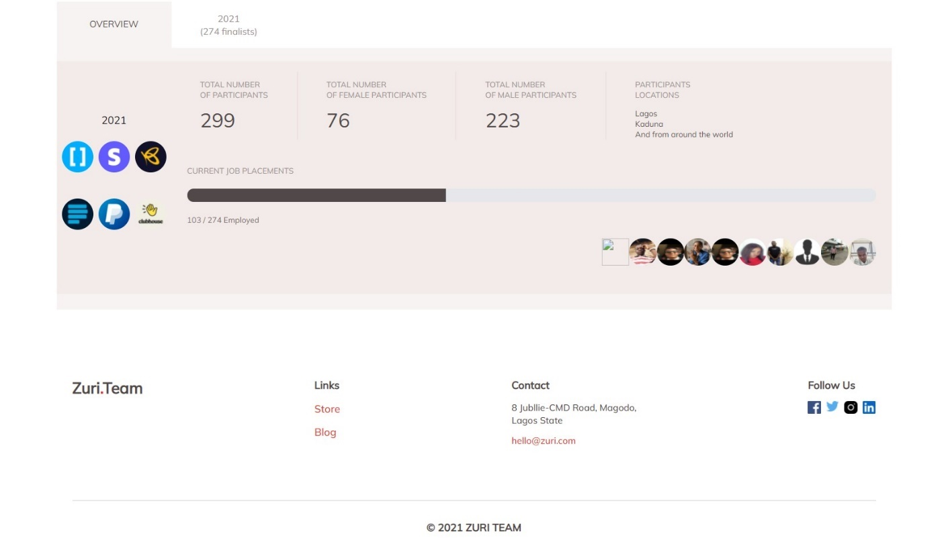

### PROJECT 7

#### Redesigned Edo State University Uzuaire Website

I and my teammates created the UI design and implemented it using Figma. We also coded it using html, JavaScript, Tailwind CSS

Link to repo:

Link to my Prs:

Live Link:

Figma link: <https://www.figma.com/file/qltlDNpjRSt1ZyMg1Hk887/Edsu-Revamp?node-id=0%3A1>

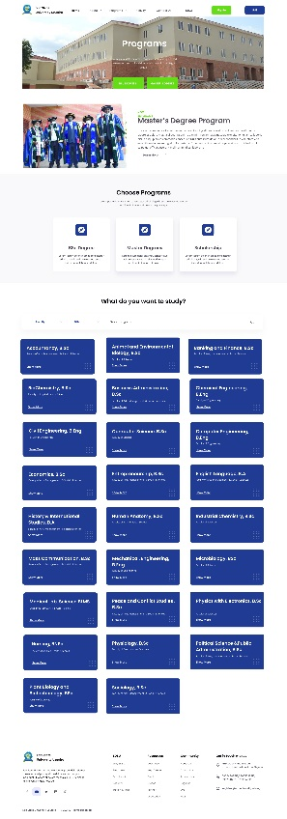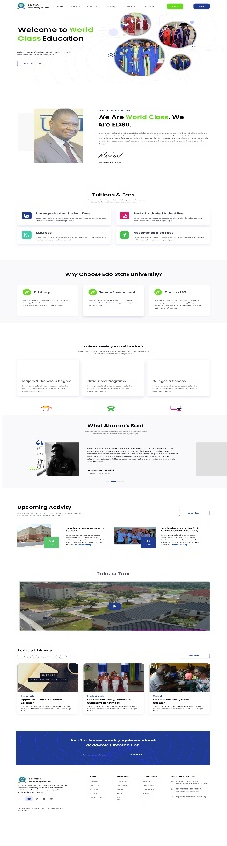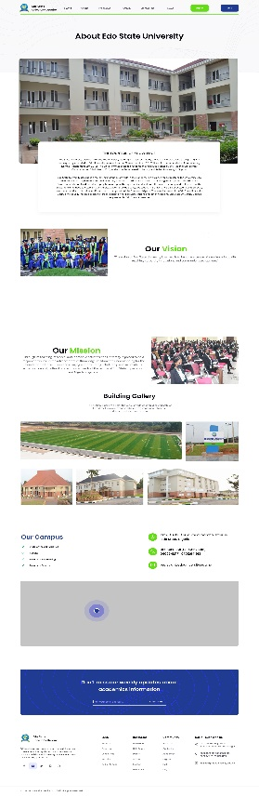

**HOME PAGE ABOUT US PAGE PROGRAMS PAGE**

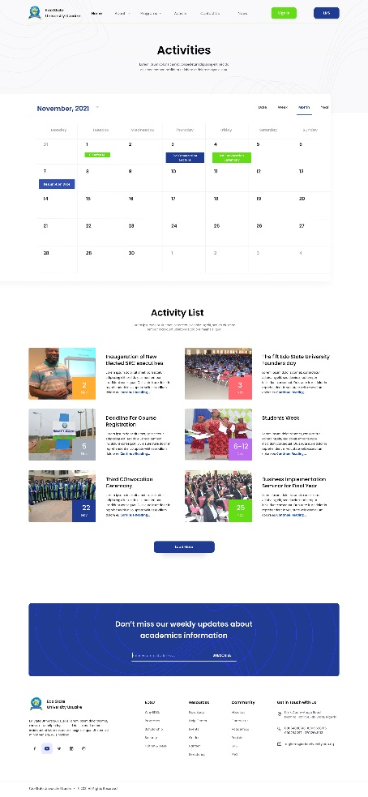 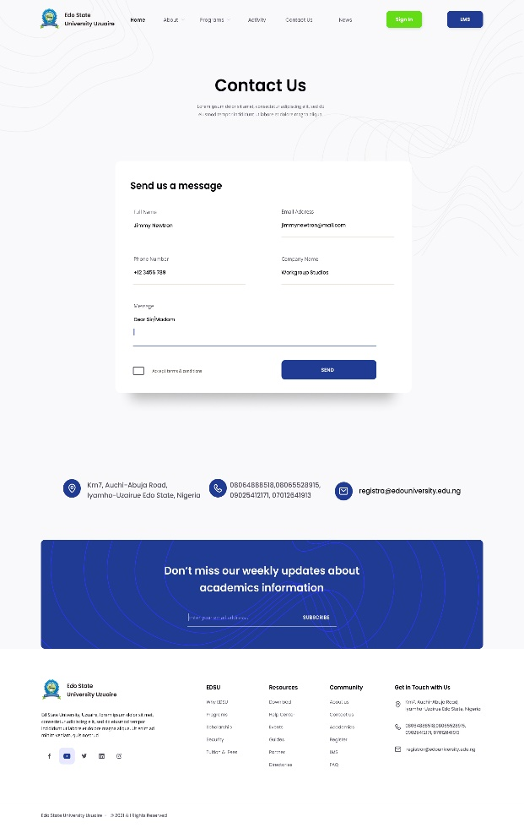

**ACTIVITY PAGE CONTACT US PAGE**

### PROJECT 8

#### Impact of Technological development on Youths in Akure South Local Government Area (Data Science Project)

#### Overview

According to statistica.com, 46.6% Nigerians makes use of the internet, as of 2020. This shows that the progress of technological development has increased across various platforms. Technological Development has played a central role in Nigerian youths, and it has raised to prominence on a global scale.

Technological Development relates to anything, regarding inventions or innovations. Development is essentially the process that takes a product or idea from a hypothesis to a usable product also known as prototype. That is, it was tested to before it could generally be accepted or fit to be used by individual for daily purpose.

In this study, the researcher’s focus is to focus on the impact technological development on youths from which one can easily find both the positive and negative attributes of technology. There are many products found in everyday use that are derived from new techniques. For example, the telephone, microwave oven, wireless phones, television, telex, electric heater, computer, air conditioner, high-speed vehicles, high sped locomotives, airplane etc. These countless inventions and technological products offer support in our daily life as well as give information across various platforms. The progress of science and technology improves the standard of living for youths and helps in managing their businesses. The living standard of the Nigerian youths in 2021 is more than double than in 1970, which mainly is the effect of the development and implementation of science and technology.

#### Statement of the Problem

This research is worth studying because, we are not aware of the impact of technological development on Youths in Akure South local government area especially in a state where there is no much development happening around. though, it has been in existence for a very long time.

#### Scope of Study

The study was restricted to youths (age 18-35) in Akure south local government area because of the aim of the research. This project will also cover youth of both gender (male and female) in Akure South local government area, Ondo state.

#### Objective of the study

As a result of the problems identified above, this study has identified the following objectives;

1. To find out the percentage of youths in Akure south local government that have gained a job or has been self-employed from Technological development in Nigeria.
2. To find out the percentage of youth that has improved on the personal development on Nigerian youths due to Technological development in Akure South local government Area.
3. To find out the percentage of youths in Akure south local government whose standard of living has improved due to the technological development in Nigeria.
4. To discover the percentage of Youth’s businesses that have grown due to Technological Development in Nigeria.
5. To discover the percentage of Youth’s that have obtained better education due to Technological Development in Nigeria.

#### Research Question

1. In What Ways Has the Technological development Improve Standard of living for Nigerian Youths in Akure South Local Government?
2. In What Ways Has the Technological development Improve Personal development among Nigerian Youths in Akure South Local Government?
3. In What Ways Has the Technological development Improve Job creation for Nigerian Youths in Akure South Local Government?
4. In What Ways Has the Technological development help in Business growths among Nigerian Youths in Akure South Local Government?
5. In What Ways Has the Technological development improve Education among Nigerian Youths in Akure South Local Government?

#### Significance of the study

1. This will help in creating awareness as technology can play a major role in the education obtained by youths.
2. This will reduce the rate of Unemployment of youths in Akure south local government area.
3. This will promote businesses owned by youths and help them in managing their businesses.
4. This will improve the personal development on youths.

#### METHODOLGY

This chapter deals with research design which includes research hypothesis, population of study sample, sample frame and sampling technique, the research methods used, validity and reliability, of the research methods, the research procedure and analysis

#### RESEARCH DESIGN

This study is to determine the impact of technological development on youths. Under this design, the questionnaires created were based on the research questions to discover the impact of technological development on youths.

#### RESEARCH HYPOTHESIS

H0:

1. There is no significant relationship between Knowledge/skills gained due to technological development and the job gained by Nigerian Youths in Akure South Local Government
2. There is no significant relationship between the improved standard of living of Nigerian Youths and the job gained of Nigerian Youths in Akure South Local Government
3. There is no significant relationship between the improved standard of living due to technological development and growth of Nigerian Youths businesses in Akure South Local Government
4. There is no significant relationship between improved education due to technological development and job gained by Nigerian Youths in Akure South Local Government

H1:

1. There is a significant relationship between Knowledge/skills gained due to technological development and the job gained by Nigerian Youths in Akure South Local Government
2. There is a significant relationship between the improved standard of living of Nigerian Youths and the job gained of Nigerian Youths in Akure South Local Government
3. There is a significant relationship between the improved standard of living due to technological development and growth of Nigerian Youths businesses in Akure South Local Government
4. There is a significant relationship between improved education due to technological development and job gained by Nigerian Youths in Akure South Local Government

#### Population/Sample Frame

The sample frame for this study comprised of the youths at Akure south local government area

#### Sample Size

A sample of 385 youths were selected through simple random sampling technique and Interview. Using the formula for unknown population:

**n** = $\frac{({z)}^{2}}{4({m)}^{2}}$

**where:**

**n** = Number of sample size that are meant to be used

**m** = Margin of error (margin error of 5%)

**z** = z-score (95% confidence interval)

**n** =?

**m** = 0.05

**Z** = 1.96

**n = $\frac{({1.96)}^{2}}{4({0.05)}^{2}}$**  = 384.16 ≈ 385

#### Data Collection Procedures

This researcher administered online questionnaire to the participants (Youths) via social media platforms after telling them the purpose of the exercise and assuring them that information volunteered by them would be treated as strictly confidential and used for the purpose of this research only.

#### Method of Analysis

The collected data from the respondent was analyzed using descriptive analysis

#### Statistical Test

The collected data from the respondent was analyzed using chi-square test

## 3.3 EXPERIENCE ACQUIRED

### Working with some Software’s:

I was able to use software such as Anaconda and Figma. Prior to the IT era, this software was not available. I also improved my knowledge of vscode and learned how to use extensions I've never heard of.

### **Working with Version Control System (Git and Github**):

The version control system Git helps you record all changes to a file or dataset, and you can call a specific version at any time you need it. It's also very useful when working in teams, especially when working remotely. My github profile link is <https://github.com/oghene-ella> .

### Personal relationship with people:

At the bond stage, I learned how to interact with people, but I found it difficult before the IT training.

### Working on project with a team:

I was assigned twice to work on a project as a team, which was really a great and wonderful experience because the way a project needs to be executed as a professional was learnt and also how to relate with teammates. I personally worked with 2 of my course mates.

# CHAPTER FOUR

## 4.1 PROBLEMS ENCOUNTERED

### Anaconda setup issues:

Installing the necessary IDE for learning the practical aspect of data science was really a problem for me.

### PC issues:

after installing the IDE, my system started giving me issues. There are days where it will just go off. Other days it might take about 45 -1hr to open the IDE.

### Network issues:

there were times in which my internet service provider had issues. which required me not being able to connect to the internet to do some personal research related to the activities carried out during my training.

### Running into bugs:

I must say it was tough running into bugs and staying there for a long time trying to understand why the codes were not working.

## 4.2 PROBLEMS SOLVED

1. I was able to install the IDE properly. Though, my was still giving me issues. had to manage it.
2. I was able to fix the bugs I encountered. Most of the bugs I encountered were due to my silly mistake
3. I would not say I fixed the network issue I had, but I was able to get a new sim which had network at my IT place and at home. It was more convenient and faster.

# CHAPTER FIVE

## 5.1 CONCLUSION

In summary, my internship was a wonderful and informative experience. I was able to meet and meet many people and acquire social skills. At one point I was hired to teach some freshmen to improve their communication skills.

My experience at SIWES served the main purpose of the SIWES program. It was to expose students to the real work environment and learn work ethic and industry etiquette. Education shows what life will look like after school. We believe that the experience gained from industrial training will help us to become a data scientist, UI and Ux designer and a Software Developer in the near future. I realized that I still have a lot of knowledge waiting to master it.

## 5.2 RECOMMENDATION

1. I think it would be beneficial for all Nigerian students as a whole if more organizations and institutions could focus more on intern training, as Zacrac does.
2. Schools and SIWES program coordinators should endeavour to ensure student operational connectivity to improve early student participation in the SIWES program.

# REFERENCE

1. [Dribble: https://dribble.com](Dribble:%20https://dribble.com)
2. Search Engine: <https://google.com>
3. [W3Schools: https://w3schools.com](W3Schools:%20%20https://w3schools.com)
4. Udemy: <https://udemy.com>
5. Anaconda: <https://anaconda.io>
6. Vue Js official Website: <https://vuejs.org>
7. Stack Overflow: <https://stackoverflow.com>
8. YouTube: <https://youtube.com>
9. React Js official website: <https://reactjs.org>
10. Kaggle: <https://www.kaggle.com/>